From: https://medium.com/history-of-yesterday/the-forgotten-genius-who-died-for-etiquette-22e4351478d8

The Forgotten Genius Who Died For Etiquette

Tycho Brahe led an astonishing life that included fake noses, forgotten achievements, and a fateful dinner party



Grant Piper
Follow
May 12 · 7 min read
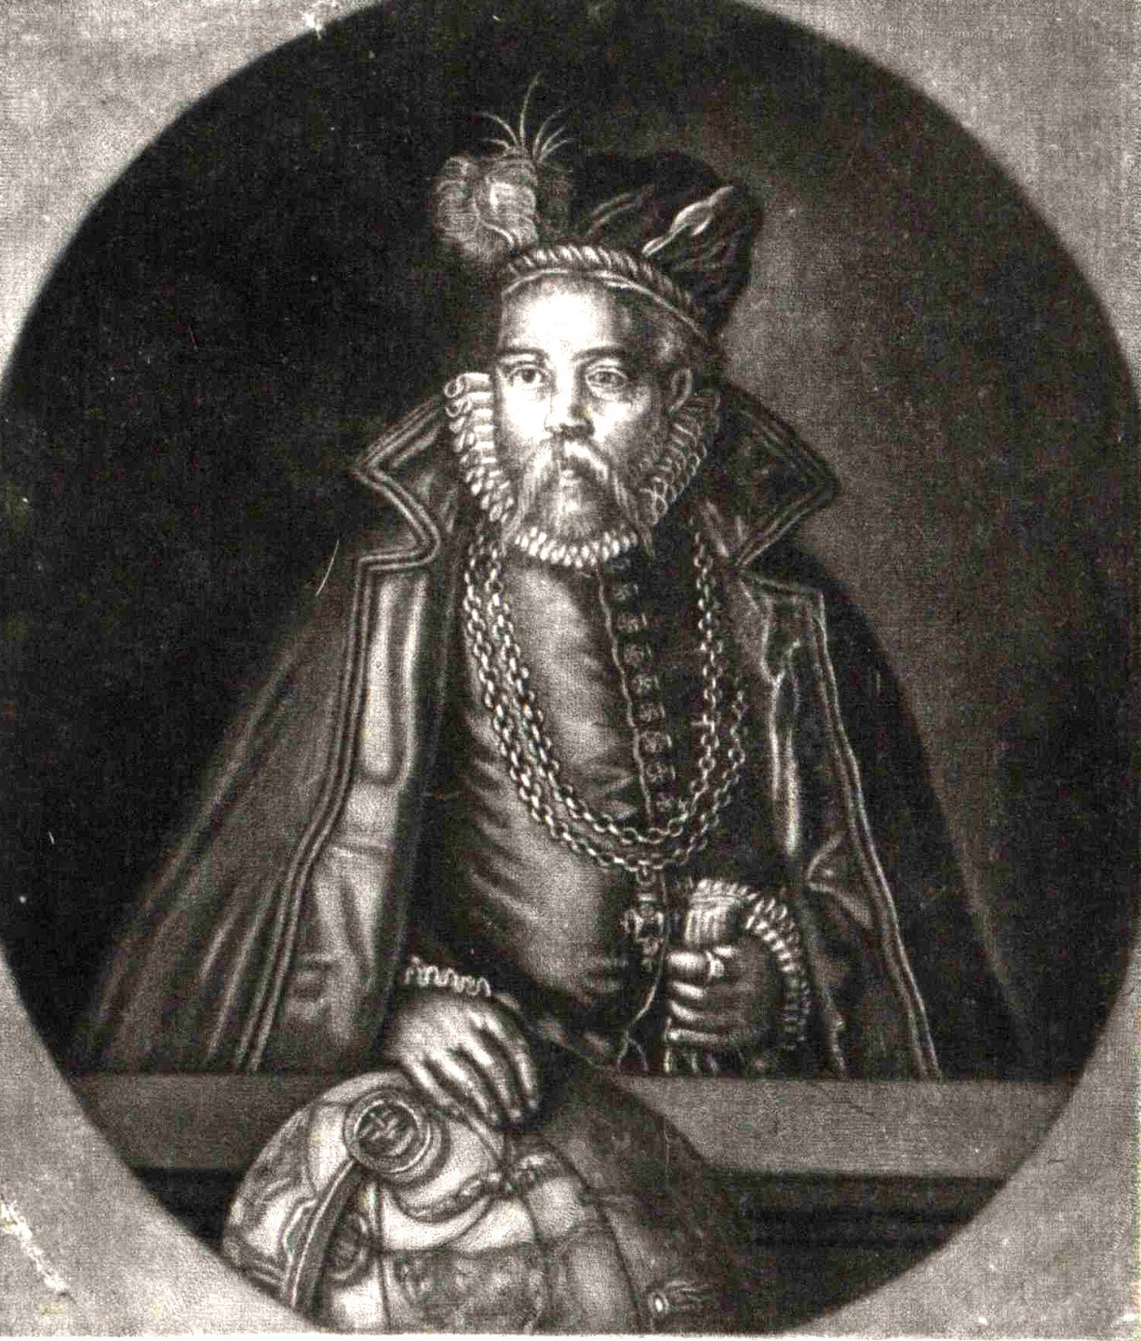
A portrait of Tycho Brahe, 17th Century portrayal
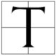The mists of history can be unkind. Due to bias, incomplete information, or simply public interest there are legendary figures who sink into near obscurity. People who think that their lives were masterful and meaningful at the time are hardly remembered by the next generation. Tycho Brahe is one such person who has, unfortunately, faded from the collective memory.
Despite his decrease in historical popularity his protege, who could not have formulated or completed his work without Brahe’s years of study and genius, is remembered very well. Tycho Brahe’s observations of the universe, his mathematical equations and out of the box thinking laid the groundwork for Johannes Kepler’s breakthrough. Kepler’s Laws of Planetary Motion are still part of basic western scientific curriculum but in the course of teaching, pupils will never hear the name Brahe.
The final stinging fact of this unfortunate wrinkle in history is what Brahe is most remembered for in the modern age is not his scientific and mathematical work but rather in the unusual way that he passed away.

Early Years
Tycho Brahe was born into the Danish nobility in 1546. Being of noble birth, he was given the best education available at the time and took to the sciences early with great enthusiasm.
As his education progressed he had gained an early reputation for mathematics and at the age of 20 went to study with some of the best minds at the University of Rostock. Their focus at the time was on medicine and alchemy, two fields that were extremely popular at the time.
It was here, in his first months at university where Brahe would be maimed for life. At a series of parties in December of 1566, Brahe and his cousin Manderup Parsberg would drunkenly argue about who was the better mathematician. The arguments got so heated that the two agreed to duel to settle the issue.
On what could only have been a dark and cold night in late December 1566 in Rostock, the two dueled with sabers. Parsberg took the advantage when he caught Brahe across the face, destroying a large portion of his nose in the process.
Brahe was rushed into the care of the best medical minds and would eventually be given a fake nose to wear in place of the one he lost. Later in life, as his prestige and mystique grew, many would claim the nose was made out of silver and gold.
Early on in life, Brahe had obtained a reputation of being brilliant yet outspoken.

Brahe Goes Supernova
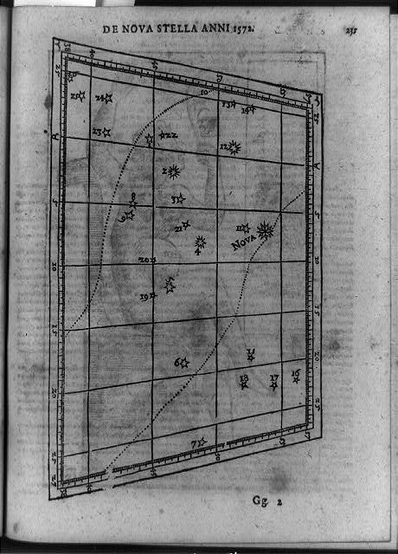
Brahe wrote about his discovery in a book titled De Nova Stella, 1572 (Library of Congress)
On the 11th of November, 1572, Tycho Brahe is the first to observe and document a supernova now known as SN 1572. Brahe correctly observed that the supernova was a new feature in the night sky, which could have groundbreaking implications on the standard scientific view at the time.
In the 16th century, many people subscribed to the ancient idea that the heavens were static and unchanging. Eternal. When Brahe sees, what he describes as a new star, appear in the firmament, it tells him that the heavens are not unchanging.
This observation made Brahe turn his focus from general sciences and alchemy to astronomy and mathematics which he would focus on for the rest of his life.
In fact, Brahe coined the term nova, from which we derived the modern term supernova. Novas, he said, were new stars. The discovery and subsequent book, De Nova Stella, became an instant hit with the European scientific community at large. His name quickly spreads and his renown went from regional to continental in a matter of months.

The Solar Model Wars
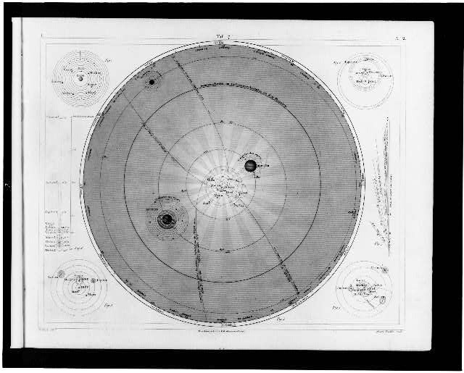
An engraving depicting all of the ancient models of the solar system (Winkles, 1860)
The late 16th century saw a deluge of mathematical and astronomical models that were attempting to depict the was the solar system behaved and operated. At the time of Brahe’s foray into astronomy there were a large number of theoretical models that were in the mainstream.
The accepted model was that of the Catholic Church which described the heavens as immutable and unchangeable. The legal doctrine promoted by the church was increasingly under siege at this time by observations from people like Copernicus, Brahe and later Galileo.
Copernicus’s model of the solar system was published in 1543 and was also widely distributed. This model was the popular heliocentric model of the universe which put the sun at the center of everything, motionless, with the Earth and the heavens orbiting around it.
It is important to note that, despite what the textbooks make it out to be, science is rarely definitive. Instead of a great moment of inspiration and acceptance, these theories percolate, exist aside one another and slowly grow or fade over time. While we see Copernicus as the father of the modern view of the solar system, his ideas were around for a long time, and alongside, many other similar models before being widely accepted at a later date. One of these models was the Tychonian model.
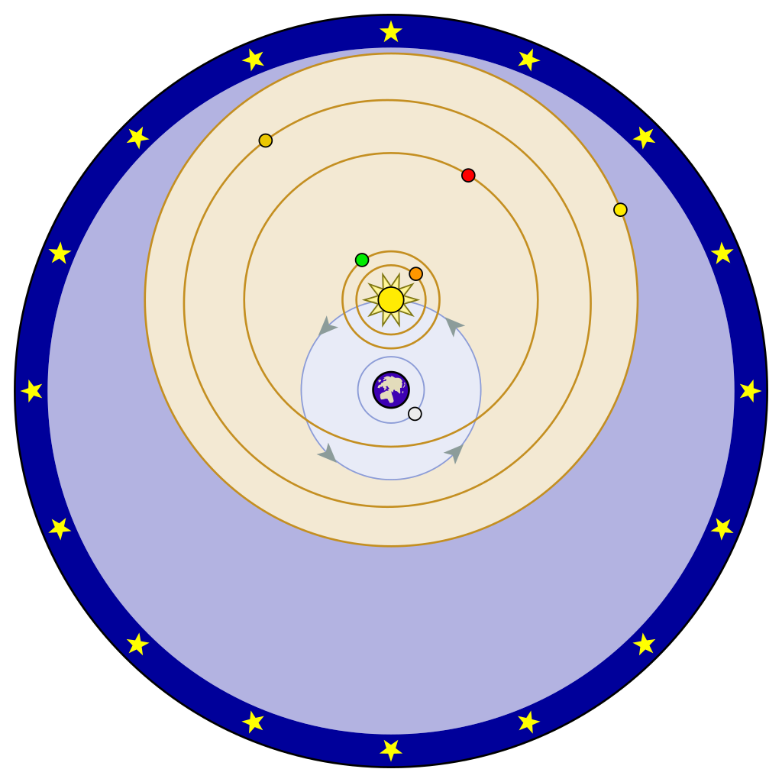
A modern recreation of the Tychonian model (Fastfission, 2009)
Brahe saw benefits to both of the systems at the time, the Ptolemaic system which was the prevalent and accepted geocentric model of the universe, as well as Copernicus’s heliocentric model. He proposed that the other observable planets revolved around the sun as they did in Copernicus’s models but that the sun and those planets were in revolution around the Earth, like the moon.
He claimed that this solved the issue of the planets being observed orbiting the sun but also explained how the heavens orbited over the Earth. He saw this as the correct blending of philosophy, observational science and religion.

The Most Unfortunate End
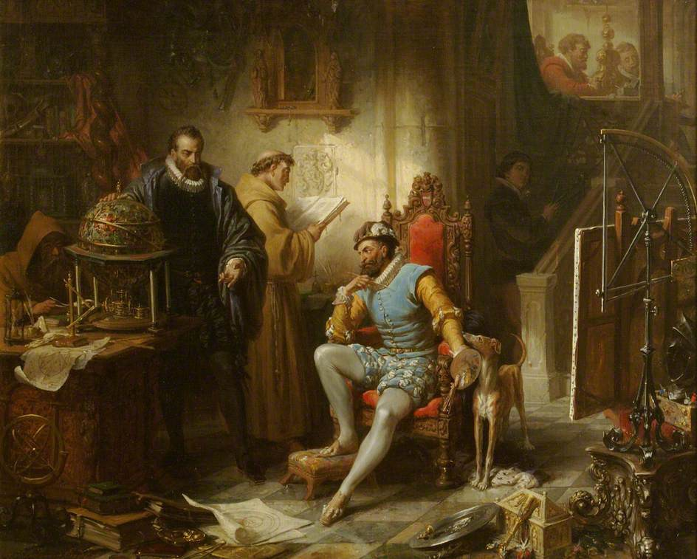
A painting of Brahe and Rudolf II in Prague (Ender, Museum of the History of Science, Oxford)
In 1599, Brahe was given the title of Imperial Court Astronomer to the Holy Roman Emperor Rudolf II and moved to Prague. In Prague he continued to do some of his greatest scientific work with financial sponsorship from the Emperor and the nobility. He brought his assistant and protege Johannes Kepler along with him. It was in Prague that Brahe made some of his greatest and most accurate observations of the heavens while serving as the Imperial Astronomer and closely shared his work with Kepler.
In 1601, the two attended a banquet. Whether the Emperor himself was present or not was not explicitly stated but there must have been royalty or other nobility present. There was much eating and drinking. According to Kepler, who was there to bear witness, Brahe refused to leave the table to relieve himself despite having to do so very badly.
It would have been improper to leave the table without express permission from the nobility and in a very relatable moment, did not want to ask on the account of a bathroom break. He suffered through the banquet, which must have ran long, without leaving the table once.
He died eleven days later.
Suffering on what would be his deathbed, Brahe wrote of himself:
He lived like a sage and died like a fool.
Observers wrote that he was in a lot of pain and had trouble urinating in the days leading up to his death. His death was a shock to many because of the suddenness of its onset and the work that he was doing.
His death was so strange in fact, that his body has been exhumed. Twice. Once in 1901 and once in 2010. Modern historians and scientists wanted to know if he had been poisoned at the banquet. He wasn’t. Then there was the burning question: Can you die from holding your pee for too long? The answer it seems, was yes.
While there is nothing left in the way of tissue there are two leading theories to what could have caused a sudden and painful death after not relieving yourself for too long. The first is uremia which is the buildup of the materials that makeup urine in the blood to the point of toxicity. The second, is that his bladder burst and he died slowly from a burst bladder.
His refusal to leave the table to take a simple bathroom break for the sake of appearances and etiquette ultimately led to his demise. In an age of strange and sudden deaths, Tycho Brahe’s continues to be one of the strangest and the most sudden in all of medieval history.

Ultimate Legacy
Tycho Brahe has always been one of my favorite figures from history. He was a genius who spent his life in the pursuit of knowledge and discovery. He rubbed elbows with kings and emperors. He lost his nose in a duel. He laid the groundwork for the astronomical revolution that would explode shortly after his death and he died from holding his pee. He is an astounding figure who I wish would get more attention from the scientific and historical communities.
In a century that saw names like Copernicus, Kepler and Galileo rise to prominence, Brahe’s name is one that is simply outshone. Despite the fact that he was instrumental in launching the entire astronomical revolution, his name no longer carries the weight it deserves. That is how history goes sometimes. Everyone stands on the shoulders of someone else and all too often we forget whose shoulders those are.
Kepler would take Brahe’s extensive notes and observations and apply them in the creation of his own model of the solar system. Kepler’s would stick but he would not have came to his conclusions without the financing, contributions and mentoring of one Tycho Brahe.

